**Make a map of your study site with tmap**

I’m loving the tmap package right now. Here’s why. And we’ll look at  
how to make a clean map of a study site as we go.

We’ll use the data from our study of [pollution and coral reefs in the  
Solmon  
Islands](https://conbio.onlinelibrary.wiley.com/doi/full/10.1111/cobi.13079?casa_token=Jk3ogcP8Wy4AAAAA%3AVcXbXq2EBCQB8dwQpM8o5ydOsblrsuIAxpwaO4QsuQwacDpNYJsbRi4hPmm64sqvrlmDr-zHmBPt)  
([repo is here](https://github.com/cbrown5/BenthicLatent)).

**It runs smoothly with sf**

sf (‘Simple Features’) is the new spatial data standard for R.

Let’s create an sf points file. First we’ll read the data from the  
github repo

sites <- read.csv(url("<https://raw.githubusercontent.com/cbrown5/BenthicLatent/master/data-raw/JuvUVCSites_with_ReefTypes_16Jun2016.csv>"))

Its a list of dive sites, where reef type, coral cover and some other  
variables were observed.

(So grateful for Rick Hamilton for letting me make this data open  
access. Just remember, there are a lot of crocodiles in the Solomon  
Islands, diving in and around mangroves to collect data like this isn’t  
the easiest job)

Now to make an sf object:

library(sf)

## Linking to GEOS 3.6.1, GDAL 2.2.3, PROJ 4.9.3

sites <- st_as_sf(sites, coords = c("coordx", "coordy"))

Let’s also get the land for context (you can download this folder from  
the github repo)

land <- st_read(dsn ="LandPoly")

Finally, the points have the same coordinate reference system as the  
polygon, so add that onto the points:

st_crs(sites) <- st_crs(land)

**You build maps as layers like in ggplot**

Maps are just a series of layers. So lets plot the land (using tmap)  
first:

library(tmap)

tm_shape(land) +

tm_polygons()

To plot a layer in tmap you say tm_shape(data_file_name) first then  
add the type of layer you want to plot (like ggplot geoms).

Now we will also want to add on the points (dive sites) layer. We can  
use tm_dots or tm_symbols for this:

tm_shape(land) +

tm_polygons() +

tm_shape(sites)+

tm_symbols(size = 0.5)

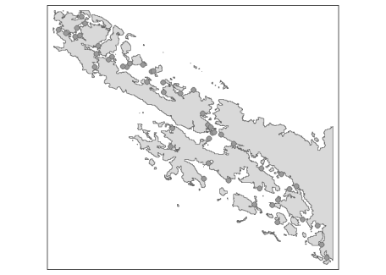

**Cartography is easy**

I mean the code for cartography is easy. Good cartography is hard (but a  
good place to start is the book ‘How to Lie with Maps’).

Now let’s keep adding on layers to make our map look nice. It’s all  
pretty self explanatory once you understand the layering concept:

tm1 <- tm_shape(land) +

tm_fill(col = "wheat") +

tm_shape(sites)+

tm_symbols(size = 0.3, col = "cover",

title.col = "Coral cover",

palette = "Reds") +

tm_compass(type = "4star", position = c(0.01, 0.67),

size = 1.5) +

#positions are between 0 & 1 and place the

#bottom left corner

tm_scale_bar(breaks = c(0, 10),

position = c(0.65, 0.01),

text.size = 0.6) +

tm_layout(legend.position = c("right", "top"),

legend.title.size = 0.8,

bg.color = "lightblue") +

tm_credits("Study sites from \nBrown and Hamilton 2018 \nConservation Biology. \nCoastline derived from Landsat.",

size = 0.7, position = c(0.01, 0.01))

tm1

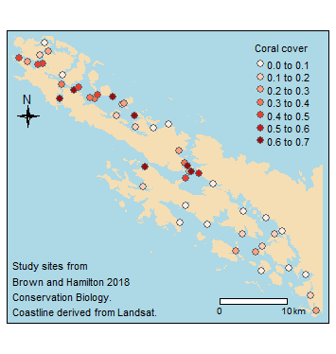

You might have to play around with the position adjustments for a while  
to get everything placed just right.

Finally, you can save your map to file

tmap_save(tm1, filename = "mymap.png",

width = 8, height = 8)